Academic Grades |  |  |  | Citizenship Grades
 | 4 | Making up credit at a high rate |  | O |   Outstanding:  on task consistently and behavior exemplary
 | 3 | Making up credit at a satisfactory rate |  | S |   Satisfactory: occasional minor rule infractions or redirections
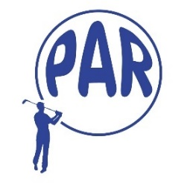 | 2 | Earning credits, but not catching up |  | N |   Needs Improvement: argumentative and/or disruptive, negative issued
 | 1 | Falling behind in credits |  | U |   Unacceptable: OC issued during the week
 | 0 | Falling further behind in credits

